**“RasCar”**

**Minor Project Report**

*Submitted in Partial Fulfillment of the Requirements for the Degree of*

**BACHELOR OF TECHNOLOGY**

**IN**

**ELECTRONICS & COMMUNICATION ENGINEERING**

By

**Meet Mehta (16bec087)**

**Parth Modi (16bec092)**



**Department of Electronics & Communication Engineering**

**Institute of Technology**

**Nirma University**

**Ahmedabad 382 481**

**November 2019**

**CERTIFICATE**

This is to certify that the Minor Project Report entitled **“Smart Features of a Modern Car”** submitted by Mr. Meet Mehta (16bec087) and Mr. Parth Modi (16bec092) towards the partial fulfillment of the requirements for the award of degree in Bachelor of Technology in the field of Electronics & Communication Engineering of Nirma University is the record of work carried out by them under our supervision and guidance. The work submitted has in our opinion reached a level required for being accepted for examination. The results embodied in this minor project work to the best of our knowledge have not been submitted to any other University or Institution for award of any degree or diploma.

**Date: 29/11/2019**

|  |  |  |
| --- | --- | --- |
| **Prof. Rutul Patel**  **Assistant Professor**  **Dr. Dhaval Pujara** |  | **Dr. Alka Mahajan** |
| **Head of Department**  Department of Electronics & Communication Engg.  Institute of Technology  Nirma University  Ahmedabad |  | **Director**  Institute of Technology  Nirma University  Ahmedabad |

Undertaking for Originality of the Work

We, Meet Mehta, (16bec087) and Parth Modi, (16bec092), give undertaking that the Minor Project entitled **“Smart Features of a Modern Car”** submitted by us, towards the partial fulfillment of the requirements for the degree of Bachelor of Technology inElectronics and Communication Engineering of Nirma University, Ahmedabad, is the original work carried out by me and I give assurance that no attempt of plagiarism has been made. I understand that in the event of any similarity found subsequently with any other published work or any project report elsewhere; it will result in severe disciplinary action.

__________________

Signature of Students

Date: 29/11/2019

Place: Ahmedabad

(Signature of Internal Guide)

## Acknowledgement

We would like to express our deepest appreciation to all those who provided us the possibility to complete this report.  A special gratitude we give to our final year project guide, Prof. Rutul Patel, whose contribution in stimulating suggestions and encouragement and investing his full effort in guiding us to achieve our targets. Furthermore, we would also like to acknowledge with much appreciation the crucial role of the laboratory supervisor, Vaibhavi mam, who gave the permission to use all required equipment and the necessary materials to complete the task. Many thanks. We have to appreciate the guidance given by other supervisors, Dr. Nagendra Gajjar and Dr. Sachin Gajjar, especially in our project presentation that has improved our presentation skills thanks to their comment and advices.

## Abstract

With more and more progress in the electronics industry and its implementation in the automobile industry, the cars we see nowadays have completely transformed. A modern car consists of many electronic systems that make the car much smarter than the cars used only one decade ago. The cars used nowadays have better safety systems which makes travelling by car much safer than it used to be. Also, these electronic systems include many automations which makes the user experience much better. In this project, we have created an embedded system that includes many of the features present in the modern day car.

### Table of Contents

**Acknowledgement iv**

**Abstract v**

**Table of Contents vi**

**List of Figures vii**

**Chapter 1 8**

Background 8

Objective 8

Scope 9

Contents of the Report 9

**Chapter 2 10**

Components Used 10

Raspberry Pi 3B 10

Rain Drop Sensor 11

DC Motor 12

Light Dependant Resistor 13

IR Sensor Module 14

Buzzer 15

**Chapter 3 16**

Working 16

Automatic Viper System 17

Automatic Headlight System 17

Obstacle Avoidance System 18

**Chapter 4 19**

Results 19

**Conclusion 20**

**Appendix 21**

**References 23**

## List of Figures

Figure 1: Raspberry Pi 3B 11

Figure 3: Rain Drop Sensor 12

Figure 4: DC Motor Circuit Diagram 12

Figure 5: LDR Symbol 13

Figure 6: Change in resistance of LDR with respect to illumination 14

Figure 7: IR Sensor Module circuit diagram 14

Figure 8: Buzzer Module 15

Figure 9: Circuit Diagram of the Embedded System 16

Figure 10: Embedded System Block Diagram 16

Figure 11: Automatic Viper Circuit Diagram 17

Figure 12: Automatic Headlight circuit diagram 18

Figure 13: Obstacle avoidance circuit diagram 18

Figure 14: The Execution of code 19

Figure 15: Car Setup (Front View) 19

Figure 16: Car Setup (Side View) 20

# Chapter 1

## Background

The cars we see around us nowadays have a many modern innovations and are said to be much more luxurious and smarter as compared to their counterparts that were made a decade or so ago. The reason for this advancement in the automobile industry is the result of the intervention of many electronic systems in the cars we use nowadays. With more and more electronic systems entering the experience of driving a car for the user has become more and more enjoyable and smooth. One can say that the automobile industry is moving towards full automation. The most recent technology that is being developed by the engineers is self-driving cars. These cars can drive on their own without the driver’s intervention. The algorithms developed for self-driving cars are based on machine learning and these algorithms have become so efficient that companies have started testing these cars on the roads with pedestrians and other cars. The concept of self-driving cars is also being used in the field of space exploration. Exploring other planets and the moon where sending human beings, is not quite possible now, can be done using unmanned vehicles. These unmanned vehicles can collect samples, do experiments, can map the terrain of the planet and everything else a human being could do. All these functions that a car can do makes the car much more expensive than it used to be and although consisting of such advanced features an average user is not able to afford a car with all these features. If these features can be integrated in a car cheaply and used by most of the people, then the roads can be made much safer.

## Objective

The objective of the project is to implement some of the modern-day features that are found in the modern-day car. An embedded system is designed to fulfill the above-mentioned purpose. This embedded system consists of sub-systems which fulfill the main objective. Each sub-system has its own objective to fulfill. Automatic Viper System Detects rainfall and activates the Vipers that dry off the windshield. The automatic headlight system detects the amount of ambient light present if the value of the ambient light is below a threshold level than the LED headlights of the car are turned on. Lastly, the object avoidance system detects a presence of an obstacle on the road then it sounds a buzzer and in addition to that stops the car from moving further.

## Scope

This project on installation can help the car detect objects lying on the way of the car and can save the car from the collision. Also, this system can automatically deploy the viper system and the headlights of the car without any user intervention. The limitation of the automatic viper system is that it cannot detect fog and cannot initiate the vipers when the atmosphere is very foggy and only can initiate the vipers when water is detected on the sensor. The obstacle avoidance system cannot stop the car when the car is travelling at high speeds as the infrared sensors used for obstacle detection have a range limitation and at high speeds the braking system gets a relatively less time to stop the car and thus it is difficult to stop the car at high speeds in order to avoid collision.

## Contents of the Report

* The list of components used in the project and specifications and other details about these components is provided.
* The working of the overall embedded system and the all the sub-systems is explained in detail.
* Results generated by the trial run of the system are also included.
* The entire code used to implement the system is included in the appendix.

# Chapter 2

## Components Used

The list of components used in this project by us is as follows:

1. Raspberry Pi 3B
2. Rain Drop Sensor
3. DC Motor
4. Light Dependent Resistor
5. Infrared Sensor
6. Buzzer
7. Chassis

# Raspberry Pi 3B

The Raspberry Pi 3 Model B is the earliest model of the third-generation Raspberry Pi. It replaced the Raspberry Pi 2 Model B in February 2016.

The specifications of the Raspberry Pi 3B include:

* Quad Core 1.2GHz Broadcom BCM2837 64bit CPU
* 1GB RAM
* BCM43438 wireless LAN and Bluetooth Low Energy (BLE) on board
* 100 Base Ethernet
* 40-pin extended GPIO
* 4 USB 2 ports
* 4 Pole stereo output and composite video port
* Full size HDMI
* CSI camera port for connecting a Raspberry Pi camera
* DSI display port for connecting a Raspberry Pi touch screen display
* Micro SD port for loading your operating system and storing data
* Upgraded switched Micro USB power source up to 2.5A [1]

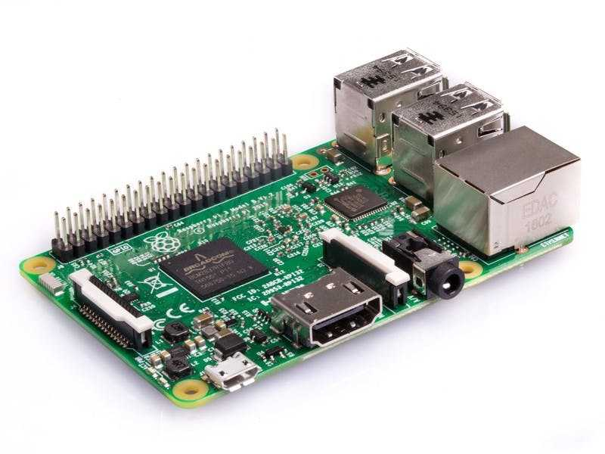

Figure 1: Raspberry Pi 3B [1]

## Rain Drop Sensor

The rain sensor module is an easy tool for rain detection. It can be used as a switch when raindrop falls through the raining board and for measuring rainfall intensity. The module features, a rain board and the control board that is separate for more convenience, power indicator LED and an adjustable sensitivity though a potentiometer. The analog output is used in detection of drops in the amount of rainfall. Connected to 5V power supply, the LED will turn on when induction board has no rain drop, and DO output is high. When dropping a little amount water, DO output is low, the switch indicator will turn on. Brush off the water droplets, and when restored to the initial state, outputs high level [2].

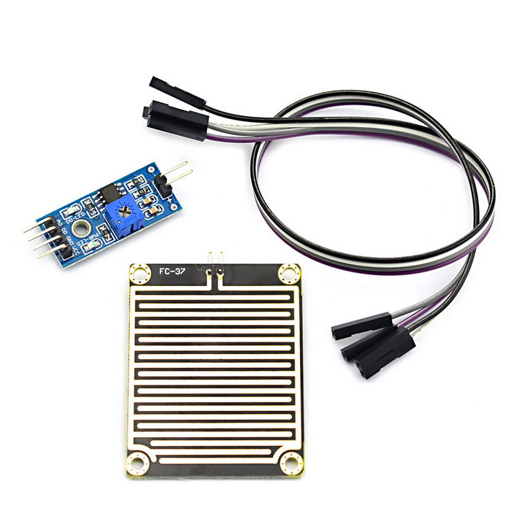

Figure 3: Rain Drop Sensor [2]

## DC Motor

The electric motor operated by dc is called dc motor. This is a device that converts DC electrical energy into a mechanical energy.

When a current carrying conductor is placed in a magnetic field, it experiences a torque and tends to move. In other words, when a magnetic field and an electric field interact, a mechanical force is produced. The DC motor or direct current motor works on that principal. This is known as motoring action.

The direction of rotation of this motor is given by Fleming’s left-hand rule, which states that if the index finger, middle finger, and thumb of your left hand are extended mutually perpendicular to each other and if the index finger represents the direction of magnetic field, middle finger indicates the direction of current, then the thumb represents the direction in which force is experienced by the shaft of the DC motor [3].

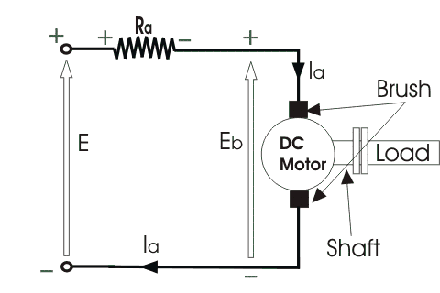

Figure 4: DC Motor Circuit Diagram [3]

## 

## Light Dependent Resistor

A Light Dependent Resistor (LDR) or a photo resistor is a device whose resistivity is a function of the incident electromagnetic radiation. Hence, they are light sensitive devices. They are also called as photo conductors, photo conductive cells or simply photocells.  
They are made up of semiconductor materials having high resistance. There are many different symbols used to indicate a LDR, one of the most commonly used symbol is shown in the figure below. The arrow indicates light falling on it.

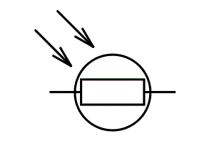

Figure 5: LDR Symbol [4]

A light dependent resistor works on the principle of photo conductivity. Photo conductivity is an optical phenomenon in which the materials conductivity is increased when light is absorbed by the material.  
When light falls i.e. when the photons fall on the device, the electrons in the valence band of the semiconductor material are excited to the conduction band. These photons in the incident light should have energy greater than the band gap of the semiconductor material to make the electrons jump from the valence band to the conduction band. Hence when light having enough energy strikes on the device, more and more electrons are excited to the conduction band which results in large number of charge carriers. The result of this process is more and more current starts flowing through the device when the circuit is closed and hence it is said that the resistance of the device has been decreased. This is the most common working principle of LDR [4].

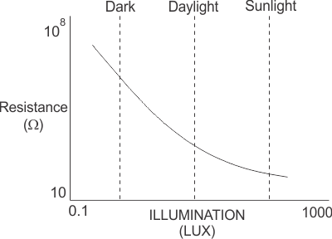

Figure 6: Change in resistance of LDR with respect to illumination [4]

## IR Sensor Module

An infrared sensor is an electronic device that emits in order to sense some aspects of the surroundings. An IR sensor can measure the heat of an object as well as detects the motion. These types of sensors measure only infrared radiation, rather than emitting it that is called as a passive IR sensor. Usually in the infrared spectrum, all the objects radiate some form of thermal radiations. These types of radiations are invisible to our eyes that can be detected by an infrared sensor. The emitter is simply an IR LED (Light Emitting Diode) and the detector is simply an IR photodiode which is sensitive to IR light of the same wavelength as that emitted by the IR LED. When IR light falls on the photodiode, the resistances and these output voltages, change in proportion to the magnitude of the IR light received [5].

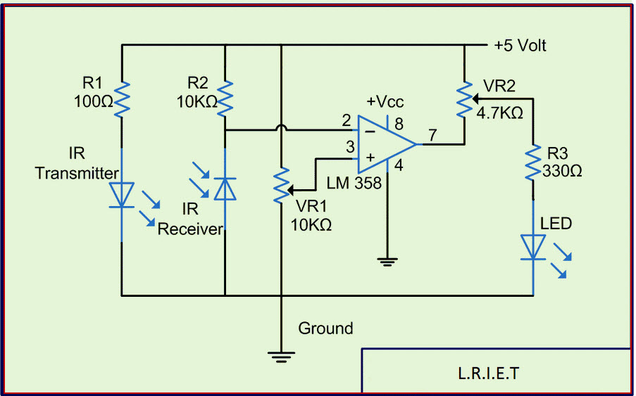

Figure 7: IR Sensor Module circuit diagram [5]

An infrared sensor circuit is one of the basic and popular sensor modules in an electronic device. This sensor is analogous to human’s visionary senses, which can be used to detect obstacles and it is one of the common applications in real time. This circuit comprises of the above components [6].

## Buzzer

A buzzeris a small yet efficient component to add sound features to our project/system. It is very small and compact 2-pin structure hence can be easily used on breadboard, Perf Board and even on PCBs which makes this a widely used component in most electronic applications.

There are two types are buzzers that are commonly available. The one shown here is a simple buzzer which when powered will make a Continuous Beep.... sound, the other type is called a readymade buzzer which will look bulkier than this and will produce a Beep. Beep. Beep. Sound due to the internal oscillating circuit present inside it. But, the one shown here is most widely used because it can be customized with help of other circuits to fit easily in our application.

This buzzer can be used by simply powering it using a DC power supply ranging from 4V to 9V. A simple 9V battery can also be used, but it is recommended to use a regulated +5V or +6V DC supply. The buzzer is normally associated with a switching circuit to turn ON or turn OFF the buzzer at required time and require interval [6].

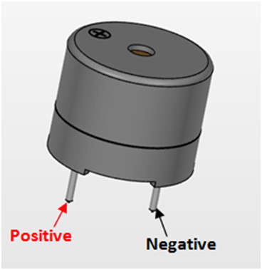

Figure 8: Buzzer Module [6]

# Chapter 3

## Working

There are three sub-systems present in this embedded system. These sub-systems work independently and communicate with the processor. The sensors of the sub-systems

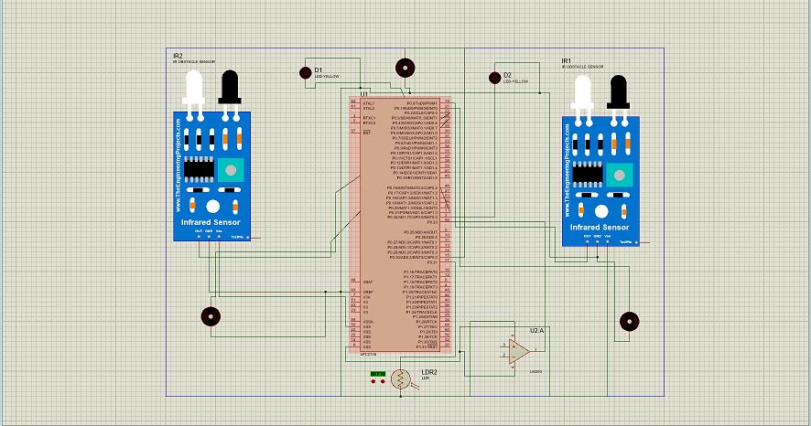

Figure 9: Circuit Diagram of the Embedded System

send data to the processor. This data is processed by the processor and according to the conditions the actuators are initialized.

Figure 10: Embedded System Block Diagram

## Automatic Viper System

The Rain drop sensor is used as the sensor in this sub-system. When the rain drop sensor gets wet it returns ‘1’ and this is detected as rain falling by the processor. In return to this the processor initiates the actuator that is the DC motor in this case.

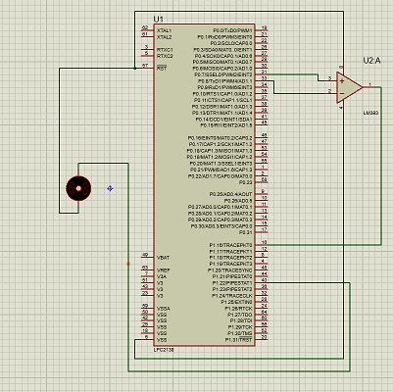

Figure 11: Automatic Viper Circuit Diagram

## Automatic Headlight System

In this sub-system the LDR is the sensor and it detects the ambient light of the surrounding and when the surrounding is dark at night time the sensor indicates this to the processor which in turn initializes the actuator that is the light emitting diode in this case and thus it can be said that the headlight is turned on.

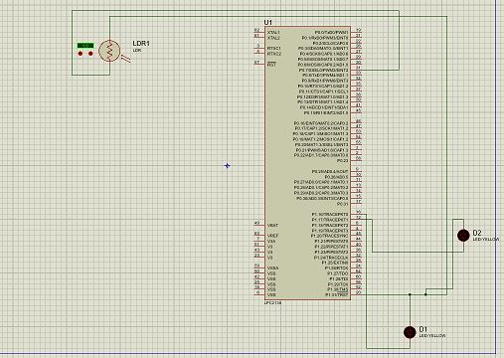

Figure 12: Automatic Headlight circuit diagram

## Obstacle Avoidance System

The Obstacle avoidance system can also be known as the automatic braking system. The IR module works as the sensor in this sub-system. As soon as an obstacle is detected in the path of the car the motors are turned off and the car stops moving and thus the obstacle is avoided.

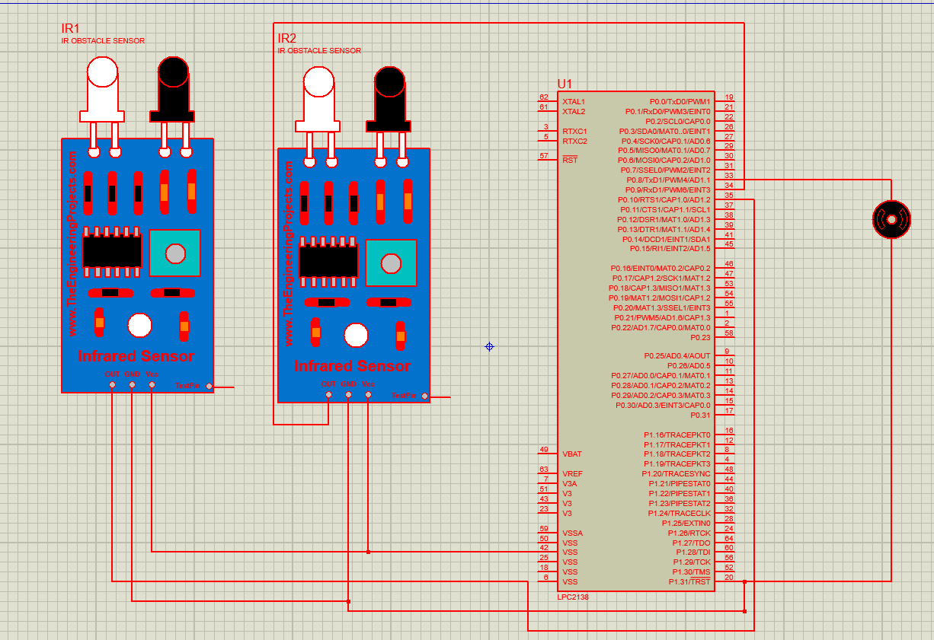

Figure 13: Obstacle avoidance circuit diagram

# Chapter 4

## Results

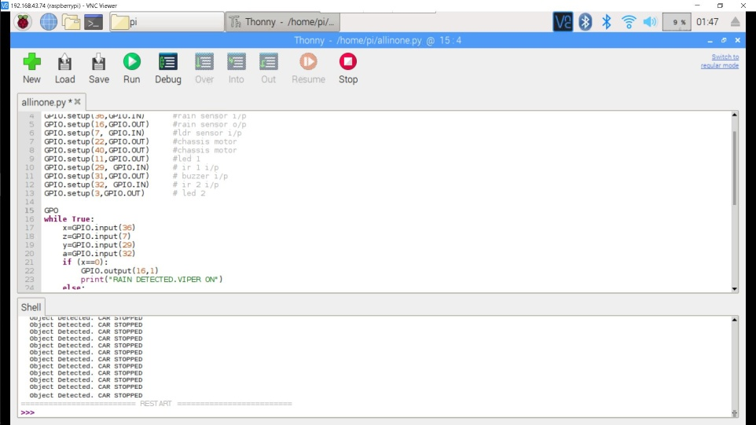

Figure 14: The Execution of code

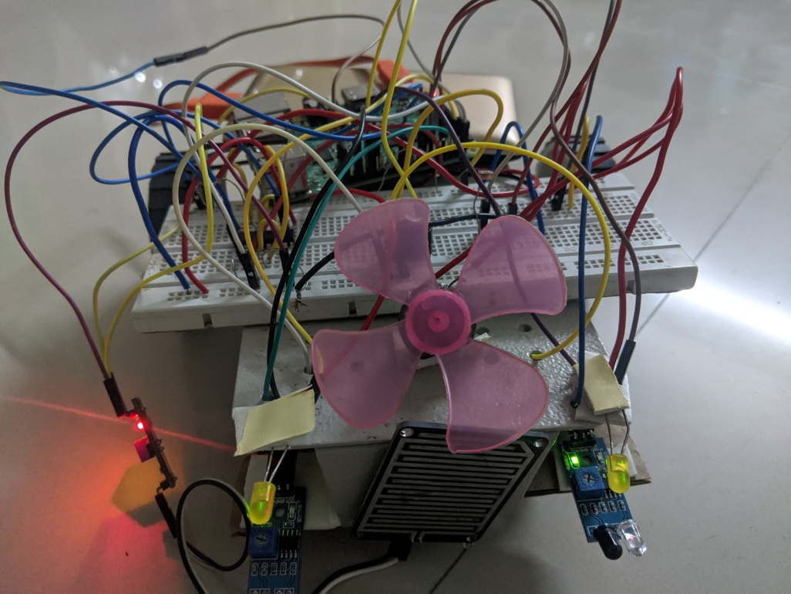

Figure 15: Car Setup (Front View)

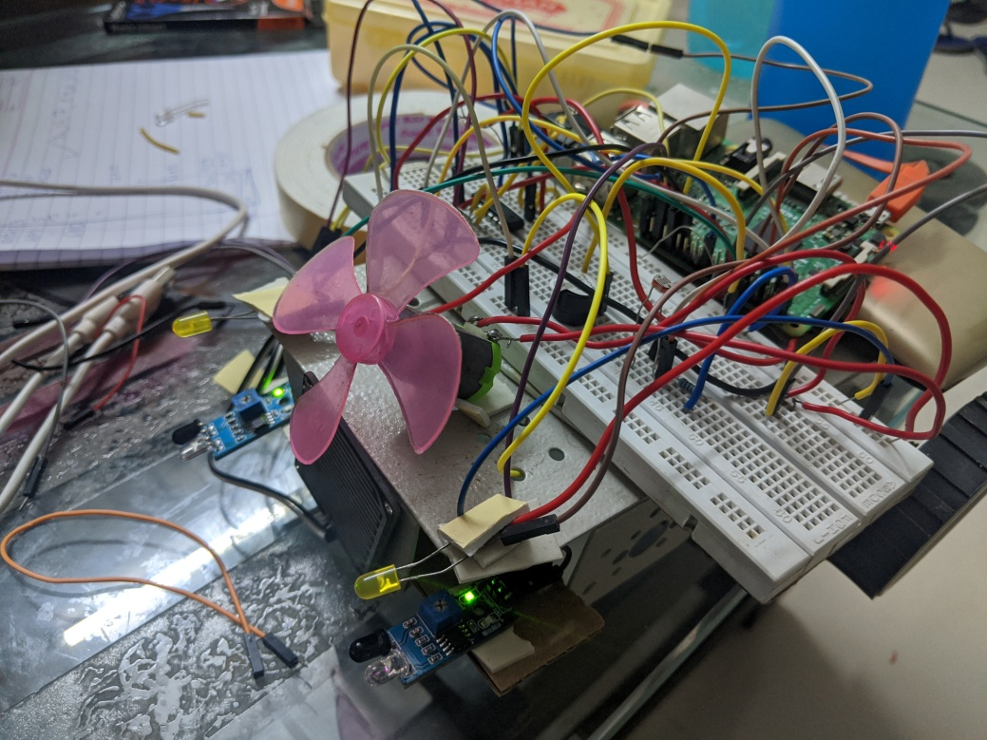

Figure 16: Car Setup (Side View)

# Conclusion

The objective of implementing all the specified features of a smart car or an unmanned rover was successfully accomplished by us. From this project we learnt and practiced interfacing of sensors with a Raspberry Pi 3B microcontroller. After implementing the given problem statements using two IR sensors, Rain drop sensor and LDR as sensors of the embedded system we found some limitations of the same. The IR sensors limit the maximum speed at which the object avoidance system can work. The maximum distance at which the IR sensors can detect an object is fixed and at greater speeds there is less time for braking and therefore at a maximum speed this system fails. Also as a limitation the rain drop sensor only works when rain is falling. Most of the times the vipers need to work when there is fog in the atmosphere but as the rain drop sensor does not detect fog, hence the system fails at this. The delays faced for the object avoidance system to stop the car when an object was detected to be 1-10 milliseconds and as this system is a hard real time system this is an acceptable delay. The delay in automatic headlight system and automatic viper system was found out to be in hundreds of milliseconds which is also acceptable as these systems are soft real time systems.

# 

# Appendix

from time import sleep  
import RPi.GPIO as GPIO  
GPIO.setmode(GPIO.BOARD)  
GPIO.setup(36,[GPIO.IN](http://gpio.in/))      #rain sensor i/p  
GPIO.setup(16,GPIO.OUT)     #rain sensor o/p  
GPIO.setup(7, [GPIO.IN](http://gpio.in/))      #ldr sensor i/p  
GPIO.setup(22,GPIO.OUT)     #chassis motor  
GPIO.setup(40,GPIO.OUT)     #chassis motor  
GPIO.setup(11,GPIO.OUT)     #led 1  
GPIO.setup(29, [GPIO.IN](http://gpio.in/))     # ir 1 i/p  
GPIO.setup(31,GPIO.OUT)     # buzzer i/p  
GPIO.setup(32, [GPIO.IN](http://gpio.in/))     # ir 2 i/p  
GPIO.setup(3,GPIO.OUT)      # led 2  
GPIO.output(22,1)  
GPIO.output(40,1)  
while True:  
    x=GPIO.input(36)  
    z=GPIO.input(7)  
    y=GPIO.input(29)  
    a=GPIO.input(32)  
    if (x==0):  
        GPIO.output(16,1)  
        print("RAIN DETECTED.VIPER ON")  
    else:  
        GPIO.output(16,0)  
    if (z==0):  
        GPIO.output(11,1)  
        GPIO.output(3,1)  
        print("HEADLIGHTS ON")  
    else:  
         GPIO.output(11,0)  
         GPIO.output(3,0)  
    if (y==0 or a==0):  
         GPIO.output(31,1)  
         GPIO.output(22,0)  
         GPIO.output(40,0)  
         print("Object Detected. CAR STOPPED")  
         m=int(input('Please enter 1 for starting car'))  
         if (m==1):  
             GPIO.output(22,1)  
             GPIO.output(40,1)    
    else:  
         GPIO.output(31,0)        
         sleep(1)  
GPIO.cleanup()

# References

1. Raspberrypi.org, 2019. [Online]. Available: https://www.raspberrypi.org/. [Accessed: 20- Nov- 2019].
2. "MaiTech Large Area Raindrop Module / Raindrop Sensor - Black", DX.com, 2019. [Online]. Available: https://www.dx.com/p/maitech-large-area-raindrop-module-raindrop-sensor-black-2042320.html. [Accessed: 20- Nov- 2019].
3. "DC Motor or Direct Current Motor | Electrical4U", Electrical4U, 2019. [Online]. Available: https://www.electrical4u.com/dc-motor-or-direct-current-motor/. [Accessed: 20- Nov- 2019].
4. "Light Dependent Resistor | LDR and Working Principle of LDR | Electrical4U", Electrical4U, 2019. [Online]. Available: https://www.electrical4u.com/light-dependent-resistor-ldr-working-principle-of-ldr/. [Accessed: 20- Nov- 2019].
5. ElProCus - Electronic Projects for Engineering Students. (2019). *IR Sensor Circuit and Working with Applications*. [online] Available at: https://www.elprocus.com/infrared-ir-sensor-circuit-and-working/ [Accessed 24 November 2019].
6. "Buzzer: Pinout, Working, Specifications & Datasheet", Components101.com, 2019. [Online]. Available: https://components101.com/buzzer-pinout-working-datasheet. [Accessed: 20- Nov- 2019].